**How to add new function to LS Omni Service**

The code for the Server and Apps are stored in separate git repositories.

Get both Repositories for the Server and the Apps. The code can be joined together, as the code in the Common folder is same in both Solutions.

Open *Server\WcfService\LSOmniService.sln*

Set Service Project as StartUp Project

Set correct connection data into *Service\AppSettings.config*

You can get this data from an already installed and running Omni Service.

**Omni Service uses three interfaces:**

|  |  |  |
| --- | --- | --- |
| **Json Interface** | **SOAP Interface** | **Usage** |
| IBOJson | IBOService | NAV to communicate back to Omni Service |
| IeCommerceJson | IeCommerceService | ECom Web sites |
| ILoyJson | IloyService | Loyalty Apps |

**The main code blocks are:**

|  |  |
| --- | --- |
| Commons\Domain.DataModel.Base | Common Data objects used all apps and Web sites and common code used by the Common Data Object |
| Commons\Domain.DataModel.Loyalty | Loyalty Data objects |
| DataAccess\BOConnection.NavSQL | LS NAV Data communication |
| DataAccess\Data.SQLServer | Local Omni Database communication |
| DataAccess\Interfaces | Interface files for DataAccess projects |
| BusinessLayer | Business Logic that takes care of calling right DataAccess code. |
| Service | Omni Service Interface code |

The most common code path is following:

The interface calls the Business Layer, that then take decision on where the code is located and calls the appropriated DataAccess code that then get the data from its source.

**Sample MyCustomFunction**

In the code, there is already a sample of a new function, which both Web Sites and Loyalty app can use. It is best to start from the end of the code path when adding a new function.

This is where the main data processing will take place

*DataAccess\BOConnection.NavSQL\NavCustom.cs*

public virtual string MyCustomFunction(string data)

{

// TODO: Here you put the code to access NAV or call NAV WS

// For NAV WS v1, existing Data Mapping is done under XmlMapping folder

// For NAV WS v2, existing Data Mapping is done under Mapping folder

// For NAV Direct Database access, code is under Dal Folder

return "My return data + Incoming data: " + data;

}

We need to add new interface for our function

*Interfaces\BOConnection\ICustomBO.cs*

string MyCustomFunction(string data);

Business Layer will open up correct BO object where our new code is and call it

*BusinessLayer\CustomBLL.cs*

public virtual string MyCustomFunction(string data)

{

return BOCustomConnection.MyCustomFunction(data);

}

All Omni Interfaces call this code, which then calls the function in Business Layer.

*Service\Common\LSOmniBaseCustom.cs*

public virtual string MyCustomFunction(string data)

{

CustomBLL myBLL = new CustomBLL();

return myBLL.MyCustomFunction(data);

}

Public interfaces

*Interface\IeCommerceService.cs & Interface\ILoyService.cs*

[OperationContract]

string MyCustomFunction(string data);

*Interface\IeCommerceService.cs & Interface\ILoyService.cs*

[OperationContract]

[WebInvoke(Method = "POST", BodyStyle = WebMessageBodyStyle.Wrapped, ResponseFormat = WebMessageFormat.Json)]

string MyCustomFunction(string data);

**Testing MyCustomFunction**

Run the solution and Internet Explorer will start up and wait like this:

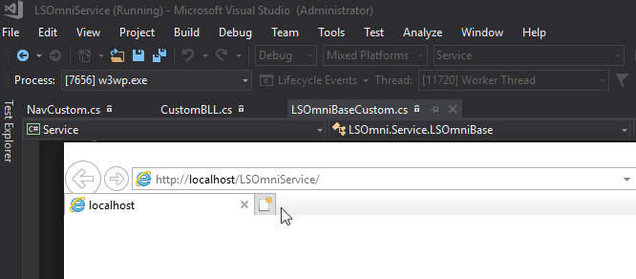

To test if the connection is working, type this into a browser

<http://localhost/LSOmniService/loyjson.svc/Ping>

If all is ok then you get this answer:

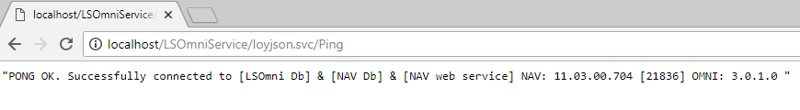

SoapUI is a free tool that can be used to test SOAP (service) interface, there we can find our new function and put in some data, run it and get the result.

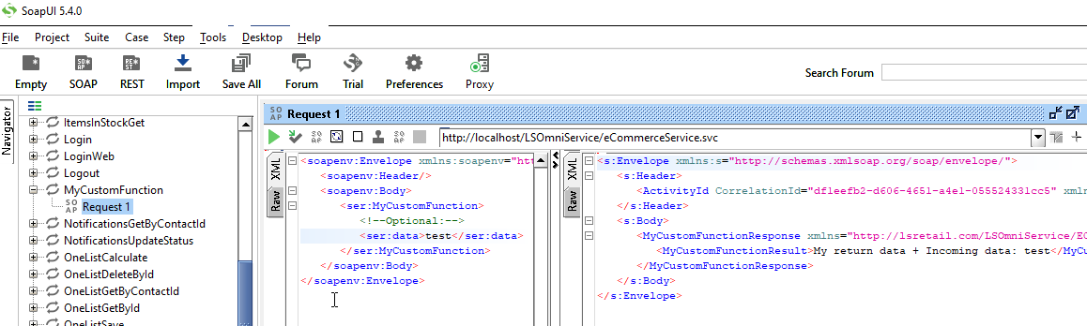

**Call MyCustomFunction from the App Code**

To add this to the Json code so Loyalty App can use the function, open up the Loyalty solution.

*Loyalty\Android\LSRetail.Mobile.Loyalty.Android.sln*

**App Code blocks are:**

Loyalty App code uses same Core as Omni Service.

Commons Data Objects are located under Domain Folder.

Infrastructure folder includes Code to talk to the Omni Service Json interface and the Local App Database.

Presentation.Android has the main App code.

This document will not go into detail on how to do the App coding, just where you would add the new function that we created in Omni Service and how to call it.

The new functions goes in to Services library, which has Interface and Service code that app, uses to call the new function. First, we add the function to the Interface

*Common\Core\Loyalty\Domain.Services.Loyalty\Custom\ICustomRepository.cs*

string MyCustomFunction(string data);

Service code has two versions of the function, one for direct call and other to call in Async mode, which the App should usually use when calling the function.

*Common\Core\Loyalty\Domain.Services.Loyalty\Custom\CustomService.cs*

public string MyCustomFunction(string data)

{

return iCustomRepository.MyCustomFunction(data);

}

public async Task<string> MyCustomFunctionAsync(string data)

{

return await Task.Run(() => MyCustomFunction(data));

}

Infrastructure then does the actual call to Omni Service Json Interface.

*Common\Core\Loyalty\Infrastructure.Data.Omniservice.Loyalty\Custom\CustomRepository.cs*

public string MyCustomFunction(string data)

{

string methodName = "MyCustomFunction";

var jObject = new { data = data };

return base.PostData<string>(jObject, methodName);

}

In the Presentation code, you would call the new function like this

private CustomService customService;

public async Task<string> MyCustomFunction(string data)

{

BeginWsCall();

return await customService.MyCustomFunctionAsync(data);

}